Algebra 1: Unit 14, Lesson 1

- Anna took a survey during her science class according to gender and shirt preference. The data she found is summarized in the list and two-way frequency table as shown.
- $5$ males prefer long sleeves.
- $7$ total students prefer long sleeves.
- $3$ females prefer short sleeves.
- $10$ students prefer short sleeves.
- $2$ males prefer sweaters.
- $13$ females were surveyed.
- There are a total of $27$ students in the class.
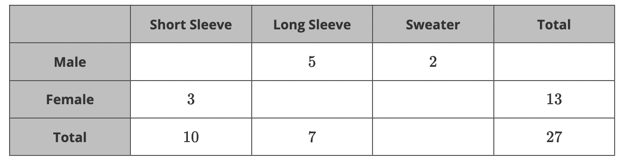
How many total males are in the class?
$$14$$

- Trevor took a class poll to see how many students play tag at recess. The results are shown in the two-way table.
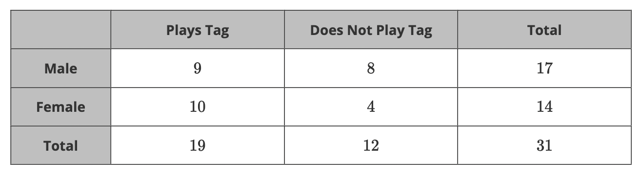
There are $19$ students who play tag at recess. This is the total of one category. What type of frequency does this number represent?
Marginal

- Jose made a class survey to see how many students drank chocolate milk or strawberry milk at lunch. The results are shown in the two-way frequency table.
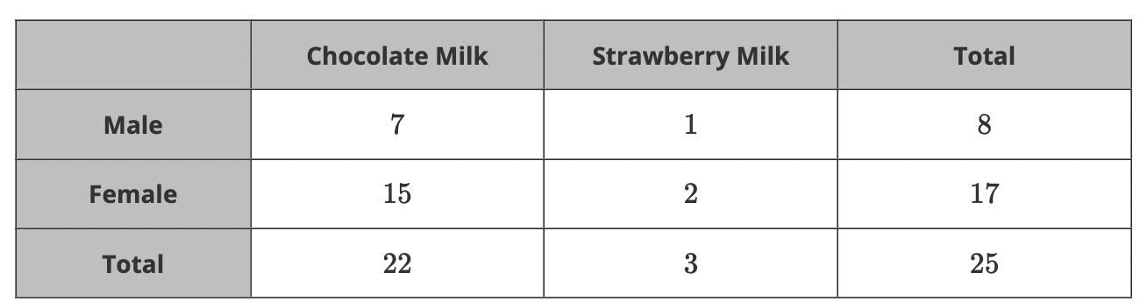
The total number of students in the class is $25$. Does this number represent a joint or marginal frequency?
Neither

